How to Create Blog in Word Press For Beginners For Free

Word Press is the most popular content management system (CMS) due to its universality : it allows to create personal and conmmunity blogs and sites, different online shops. According to stats, more than 60% of sites using CMS, created on Word Press platform. Even if you know absolutely nothing about programming, hosting, domains, you can create your own blog for free in Word Press.
Below you can see how to create your own blog in 5 minutes without paying a penny for this.

Step 1 : Enter Word Press Site

Fisrt of all you need to enter Word Press’s official site. Just type into your browser line (Google Chrome or Mozilla Firefox preferrable) these words “Word Press” and it will direct you to its official page.
When you’re in, you will see this picture, on which you’re offered to choose what kind of site you’d like to create : blog or site. Press “Start with blog”.
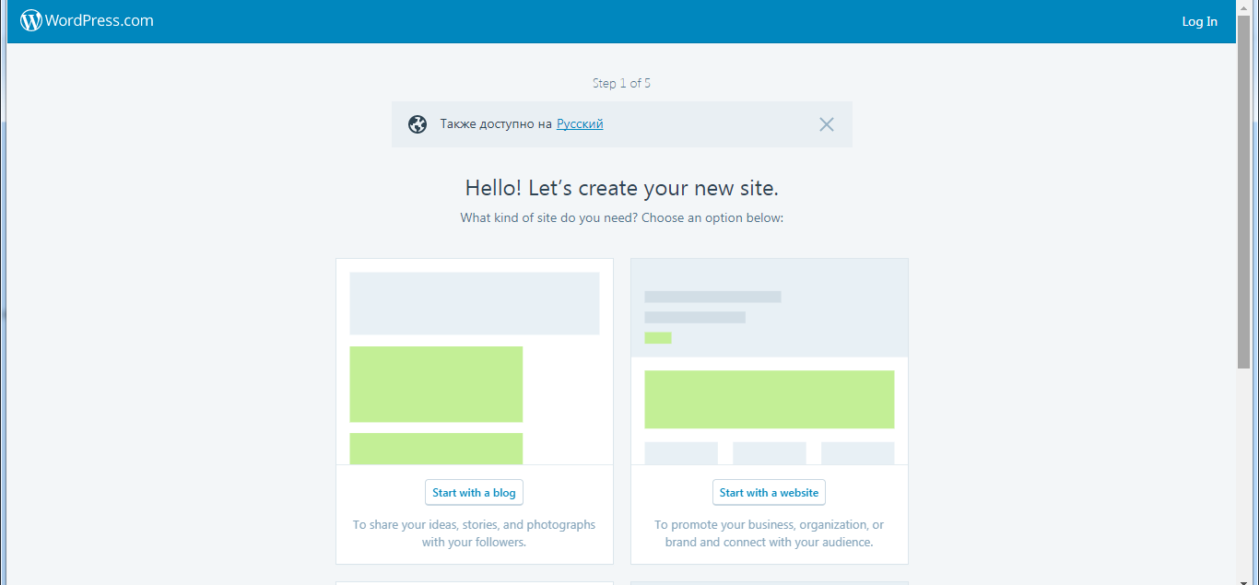

Step 2 : Name Your Blog

After this you have to choose your blog’s name.
If you wish, you can give it your own name. Honestly, no matter what name of your blog is, if you don’t want to work with it in future.
The domain (site’s name) should be short, clear and reflect your interests.
Secondly, it should be very easy to type in smartphone’s screen – more and more people prefer to use them in order to get in touch with each other constantly. For instance, you’re fond of home pets and decide to name your blog as “lovelypets”.

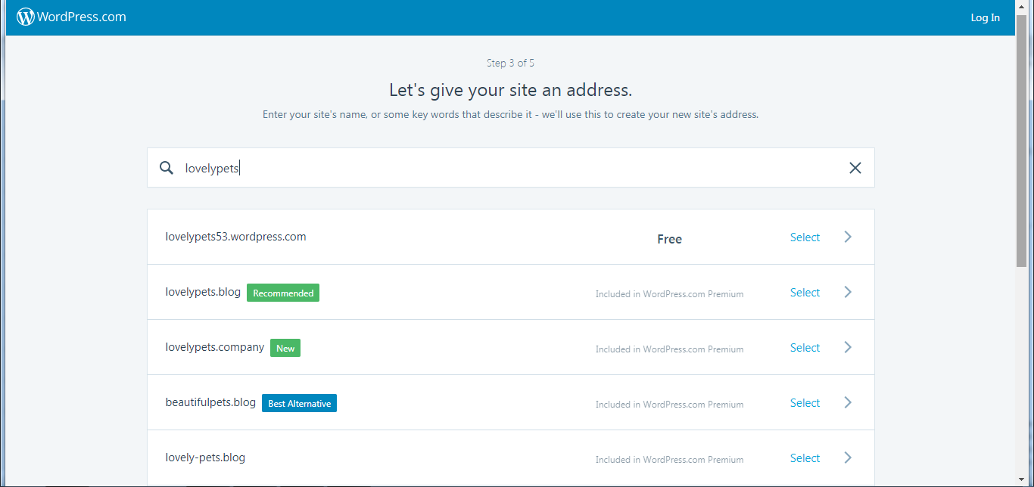
The system will define if this domain is available. If it is, you’ll be offered to choose options for payment details. We’re learning to create blog for free, so let’s continue without paying. Choose option “Free” and you’ll be directed to the next step.
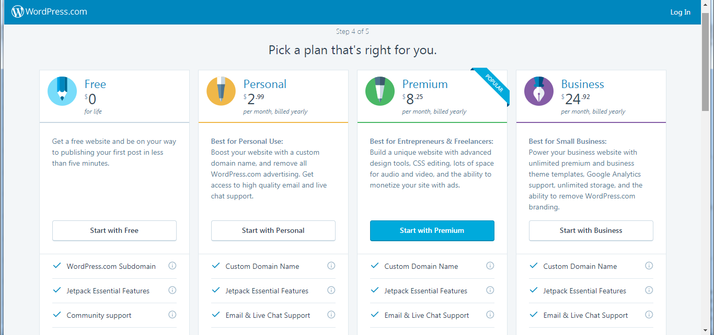
As you can see, the prices are not too high : if you wish, you can choose option “Free” or “Personal” with monthly payment for the blog.
If you choose to create a blog for free, its name will be “XXX.wordpress.com”, where “XXXX” is the name you gave to blog. In other cases the blog’s name will be without continuation “wordpress.com”. You can change domain’s options any time, just click the correct payment plan which is available for you.

Step 3 : Create Word Press Account And Verify Your E-mail Address

Next step is to create an account in Word Press.
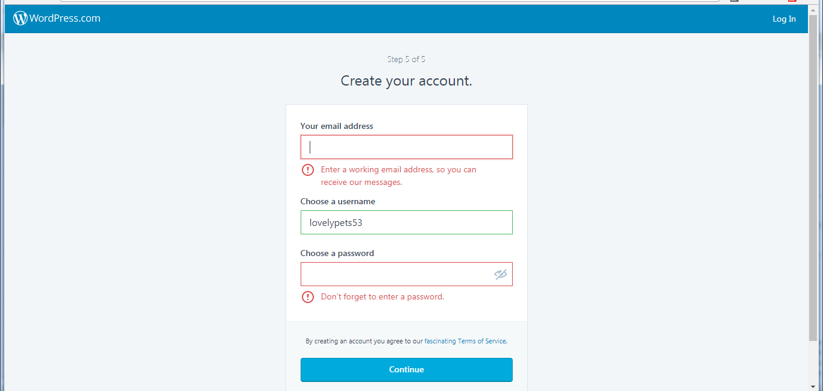
This means that you’ll have access to admin’s panel in your blog in order to edit posts, chat with visitors, place videos and so on. The email address should be actual, that you really use in your everyday activity.
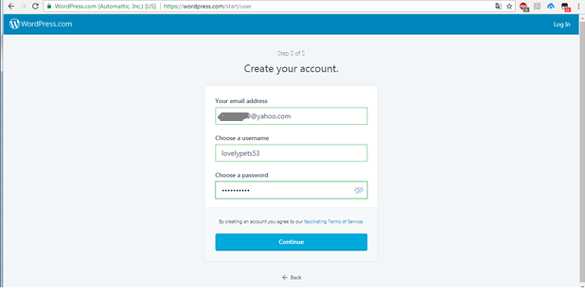
When you see such a message, you have to enter your e-mail address and password. After filling this form, press “Continue” button. Just in less than 5 minutes you’ll be sent a letter of confirmation, which looks this way (see below).
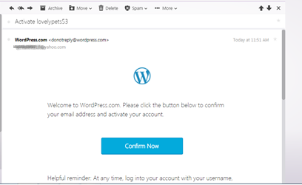
You receive a verification letter.
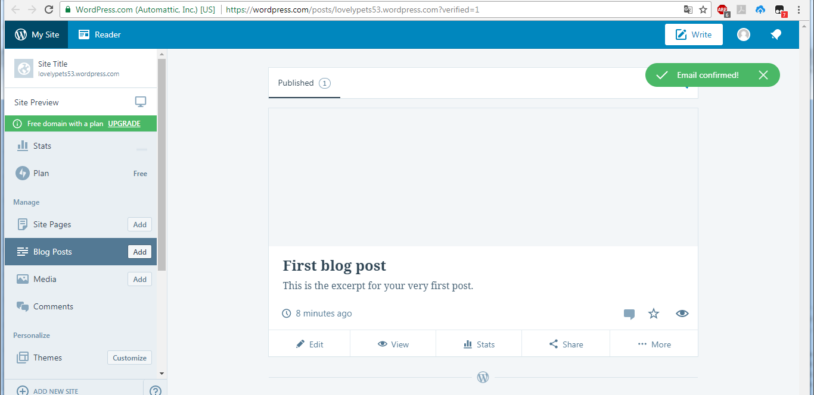

Without confirmation you won’t be able to edit anything in your blog. Press “Continue” button” and go to the next step, when you’re directed to your blog’s admin panel.
Below you see Word Press thanking you for the confirmation and you can go further.

Step 4 : Enter Admin’s Panel

Now you’re in. So you can edit all relevant info.
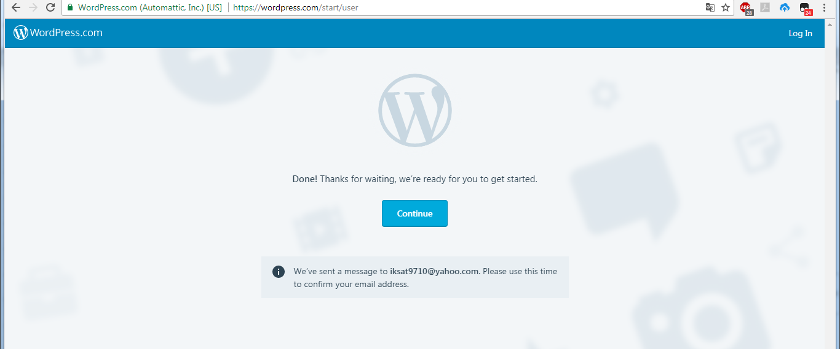
After clicking “Continue” button you enter admin’s panel, where you’ll find different settings to edit, including
- Social media widgets (you can connect your social media accounts)
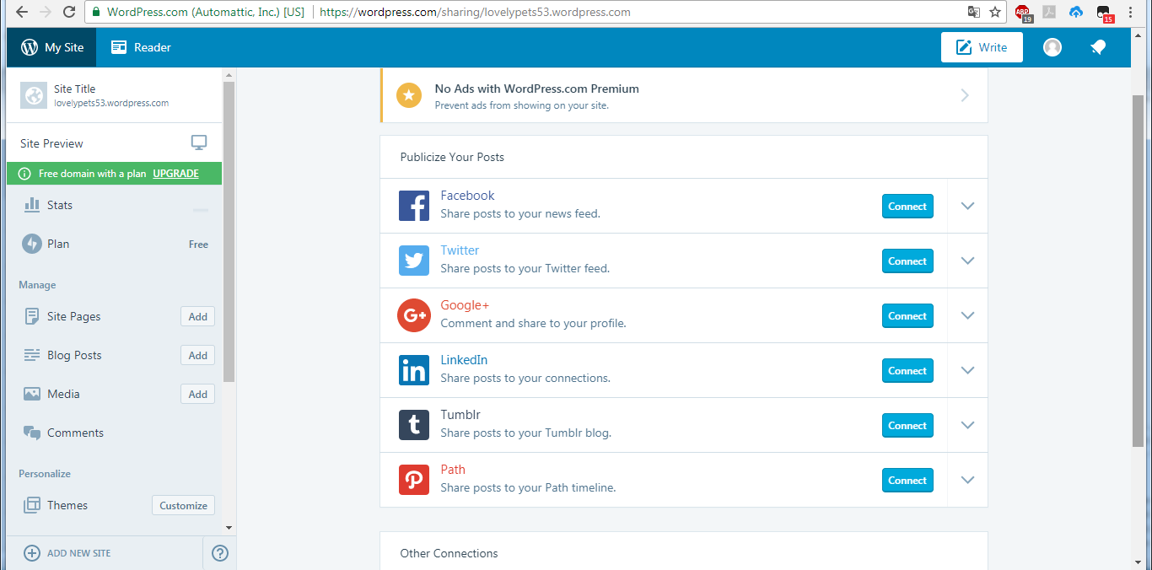
- Posts editing and publication
- Media files (where you can download pictures and videos)
- Traffic stats (number of visitors), etc.
You can choose different templates to design your blog’s welcome page and other pages, where media files and posts will be placed. It will take not too long to understand what to do, because, if you are not confident of your actions, you can use preview option (shown as a picture of eye on the panel).

Step 5 : Edit Your Blog

First thing that you have to do is to write welcome info about yourself and why your blog is useful for others. In order to edit your welcome post, press “Write” button on the right upper corner.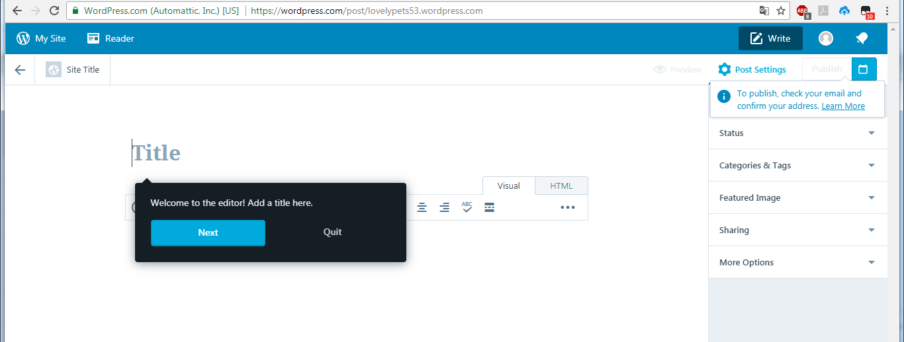
You can use available pictures in the admin’s panel or download files from net.
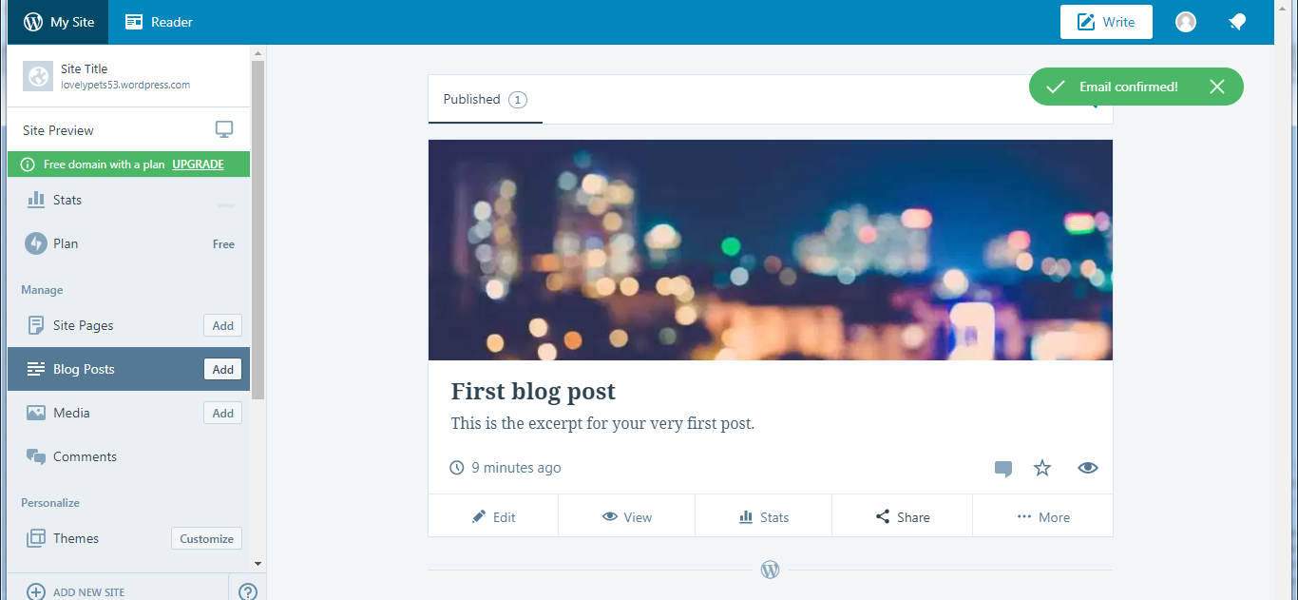
If you wish to add post or media file, just click “Add” button on the left side of the panel and this will be done.
The same way you can add pages to the blog and share them with your friends. In order to share new posts or files, click “Share” icon and you’ll be directed to the social media accounts connected to your account in Word Press.
These are your first steps to become a successful blogger. You need just to try different ways to design your posts and obtain an experience in blogging.

